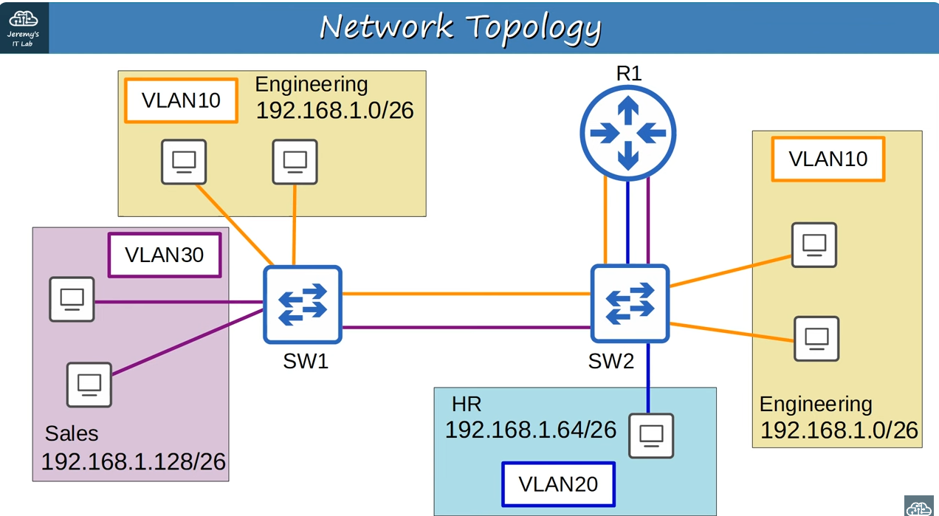
Note: VLAN10, the VLAN for the engineering department,is split between the two switches.This is very common,as departments in a company aren’t split up exactly by location.We might have some engineers on one floor of the building,for example,and some on another floor.

Note: There are two links between SW1 and SW2,one for VLAN10,and one for VLAN30.

Note: There must be a link in VLAN10 between the two switches because VLAN10 PCs are connected to both SW1 and SW2,and also because the PCs connected to SW1 need to be able to reach R1 via SW2.

Note: As for the link in VLAN30 it is necessary because PC’s in VLAN30 also need to be able to reach R1 via SW2.

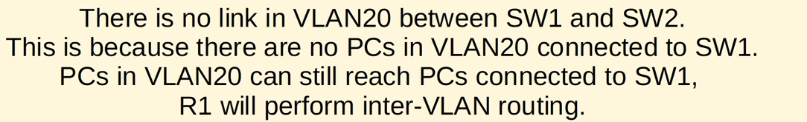
Note:

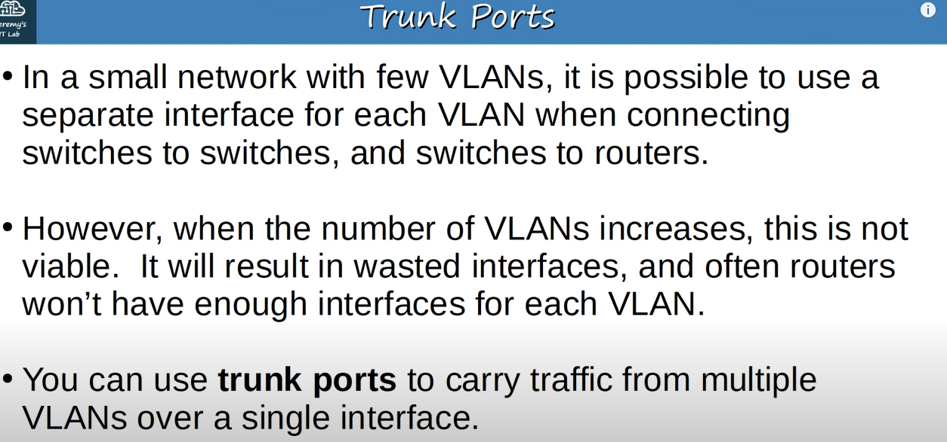
Trunk ports

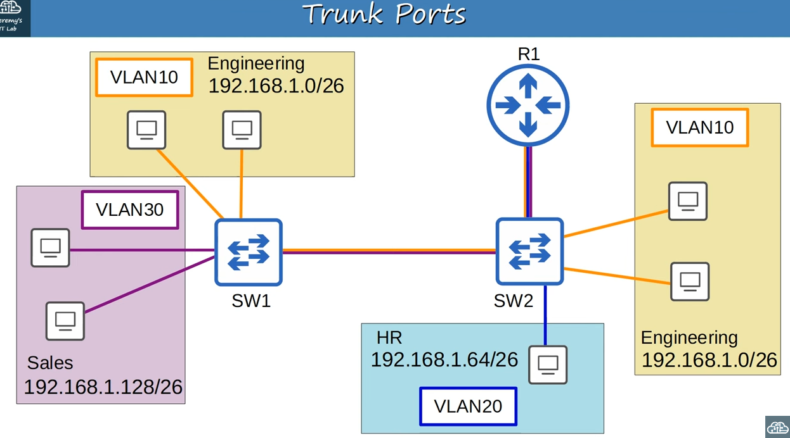
The same network topology(the same network above) with replaced separate connections to single connections

Note: Multiple colors in single connection is just for better understanding the trunk ports.Those are just single physical connections,but traffic from multiple VLANs is allowed over each trunk.

Note: Let’s say this PC in VLAN10 wants to send some data to this other PC in VLAN10.It sends the traffic to SW2 which then sends it to SW1.Both VLANs 10 and 30 are allowed on the interface the traffic was received on,but how does SW1 know which VLAN it belongs to?
The answer is VLAN tagging.
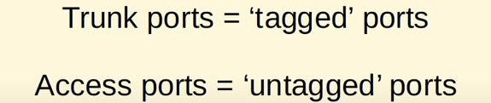
Another names for Trunk and Access ports

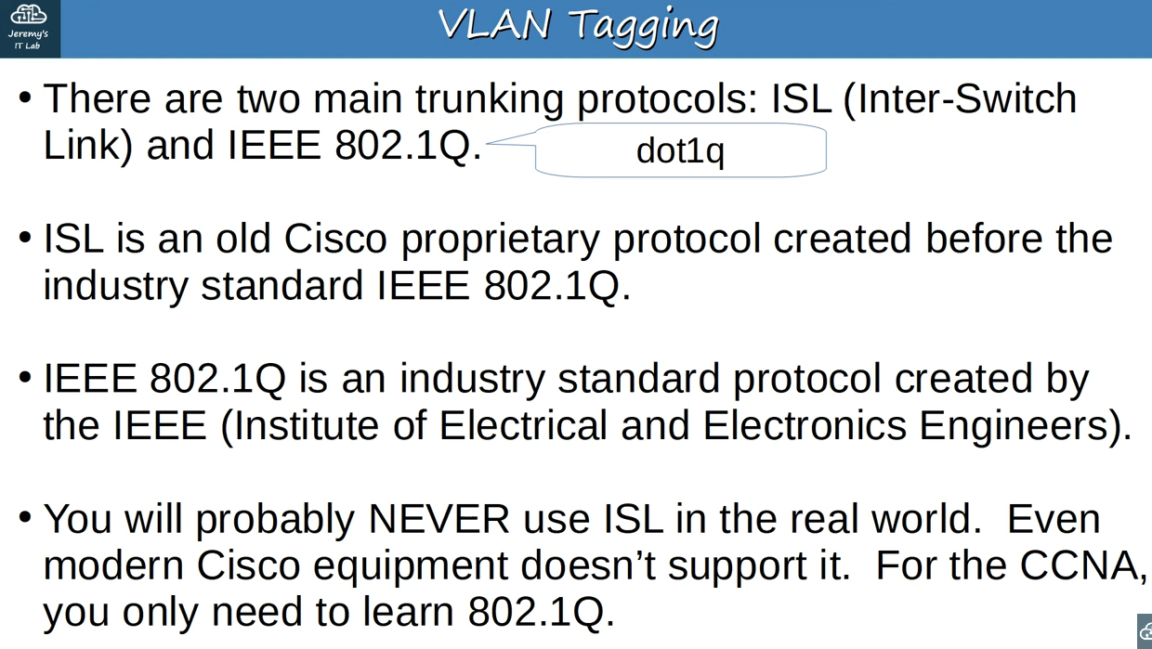
Trunking protocols



Note: dot1q(IEEE 802.1Q) is inserted between two fields of ethernet header.

Note: dot1q inserts a 4-byte(32 bit) field between two field of ethernet header.

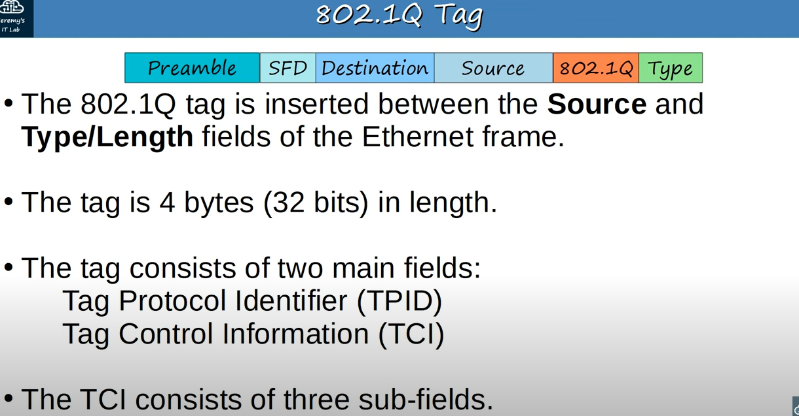
About dot1q

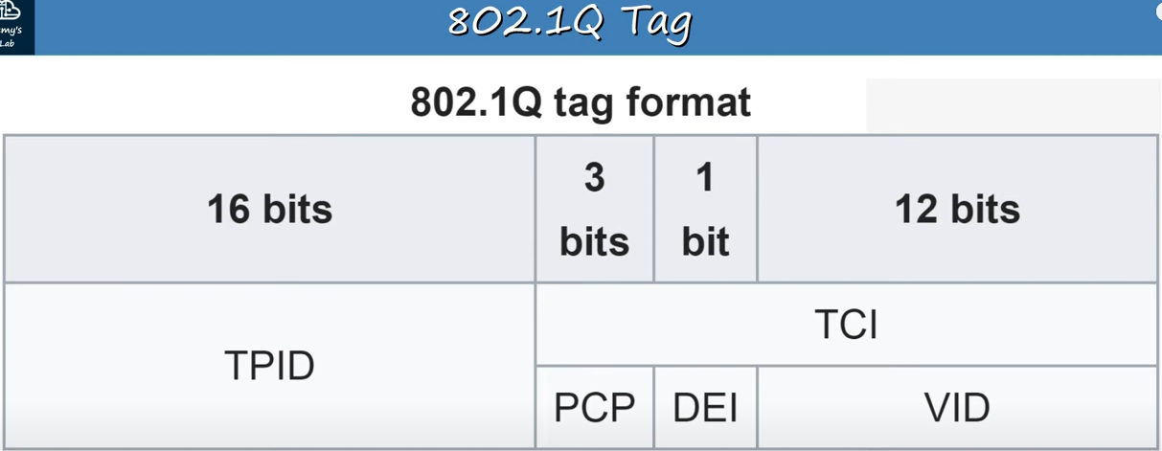
Diagram of the dot1q tag format.

Note: It is divided into two halves TPID and TCI.

Note: Here PCP DEI VID are sub fields of TCI.

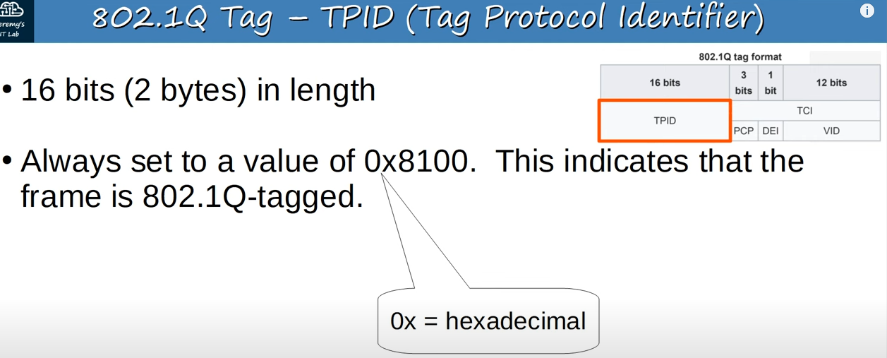
TPID field

Note: It consists of 4 hexadecimal digit.Each hexadecimal digit is 4 bit,so 4*4=16 bits is the total length of the field

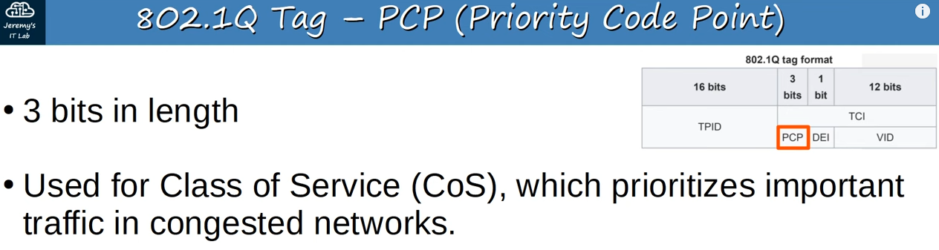
PCP field

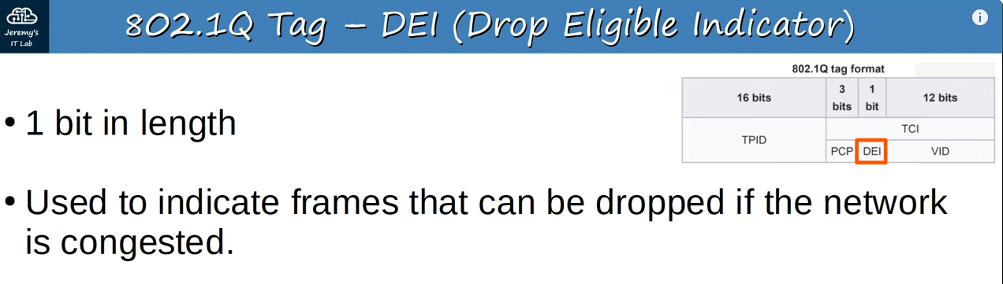
DEI field

Note: DEI makes sure more important network traffic gets through.

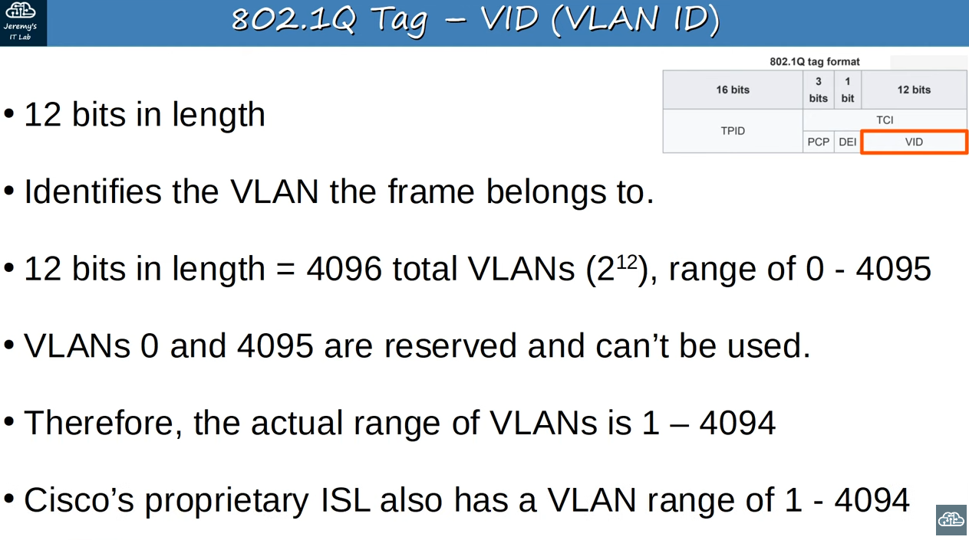
VID field

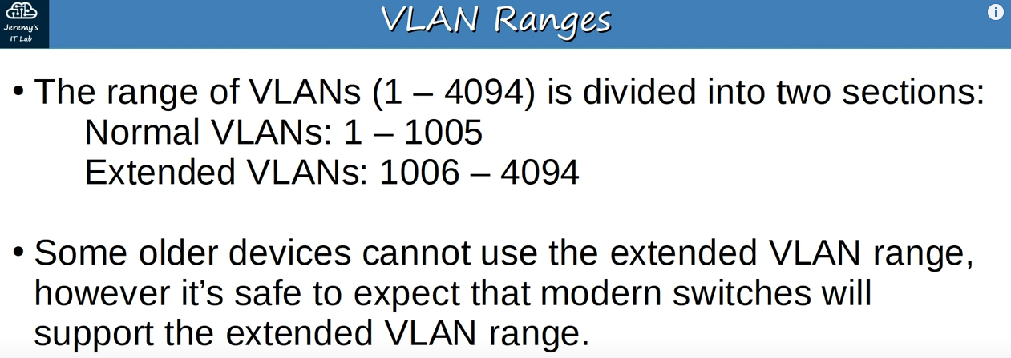
VLAN ranges

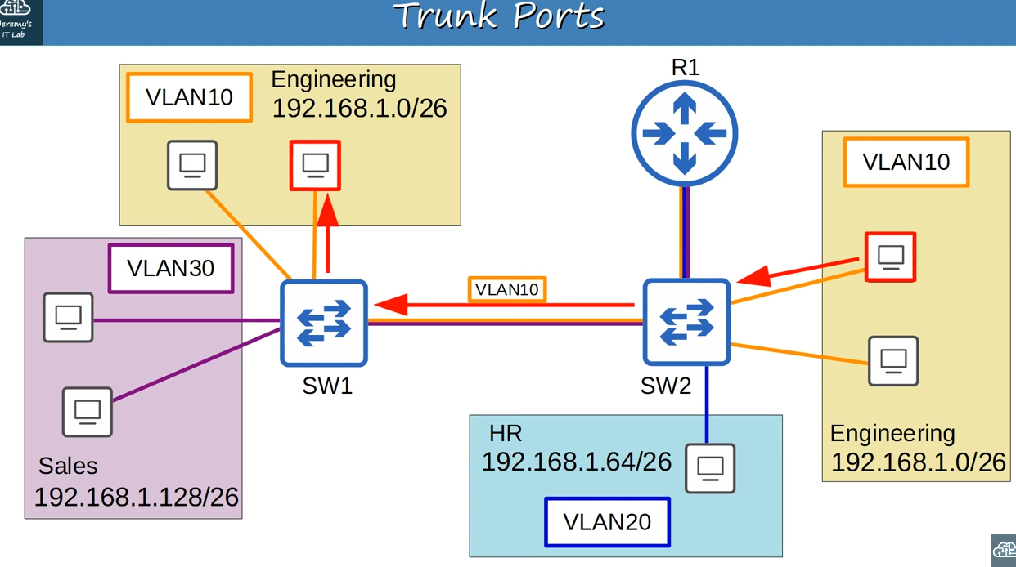
Traffic with VLAN10 tag

Note:Let’s say PC in VLAN10 wants to send traffic to this other PC in VLAN10.The traffic goes to SW2,which then forwards it to SW1 ,with a tag indicating that the traffic belongs to VLAN10.SW1 receives the frame,and because the destination is also in VLAN10,it will forward the traffic to the destination.

Note: A standard layer 2 switch like this will only forward traffic in the same VLAN,it will not forward traffic between VLANs.

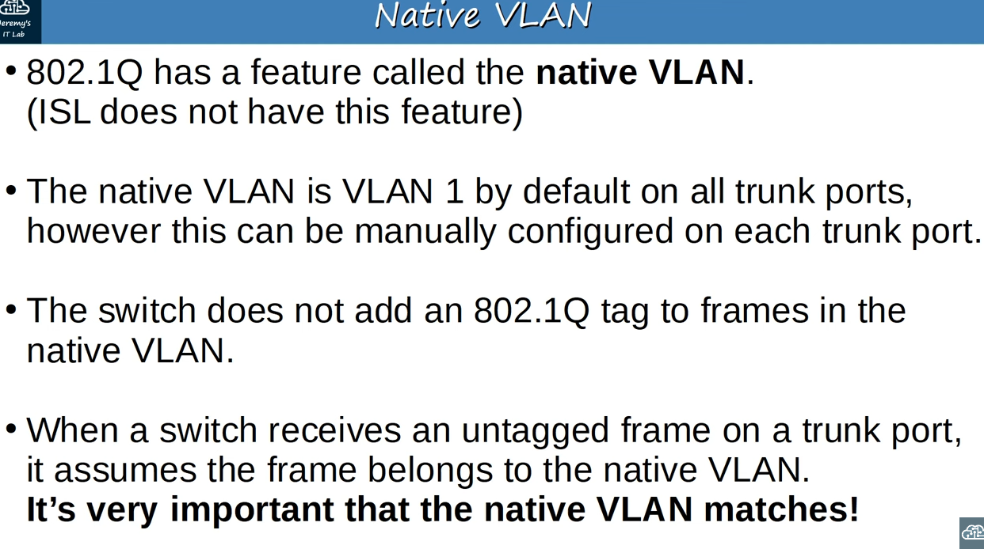
Native VLAN

Note: It’s very important that the native VLAN matches between switches.Switches will still forward traffic if there is a native VLAN mismatch,but problems may occur.

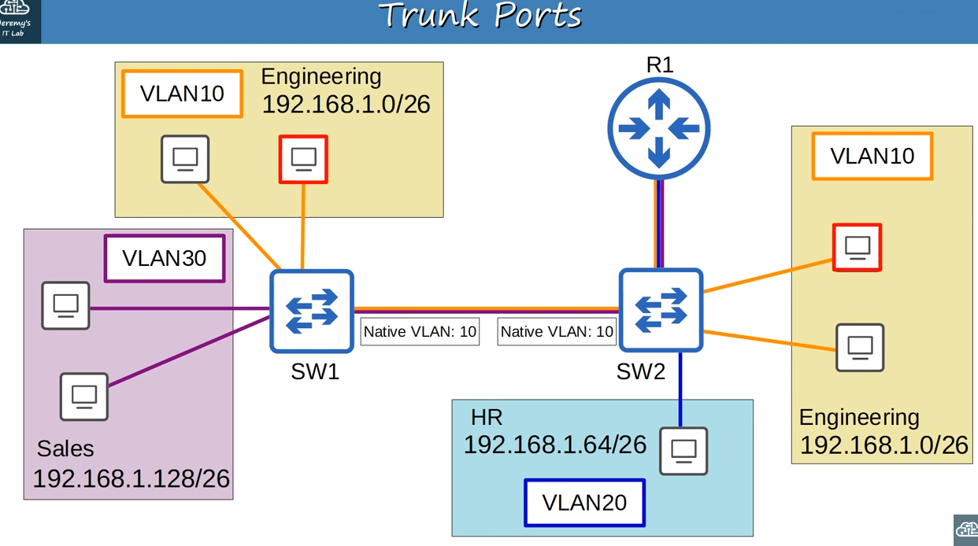
Example(with configured native VLAN10 on the trunk link between SW1 and SW2)

Note: PC in right VLAN 10 wants to send traffic to another PC in the VLAN 10 on the left,so it will send the traffic to SW2.It will send the traffic to SW1,but because it is in the native VLAN, VLAN10,it won’t tag it as being in VLAN10.The untagged frame arrives at SW1,which assumes that the traffic belongs to VLAN10,so it forwards it to the destination.

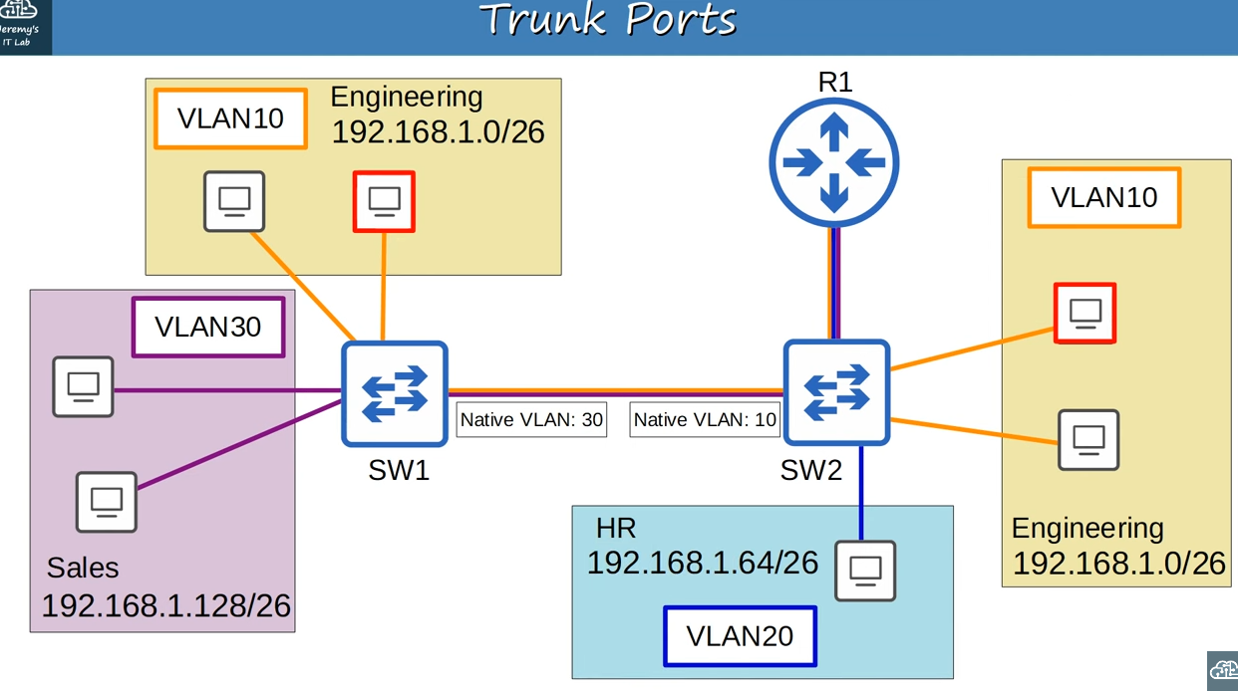
Example(with mismatch in native VLAN configuration)

Note: On SW2’s interface we’ve configured VLAN10 as the native VLAN,however on SW1’s interface we’ve configurd VLAN30 as the native VLAN.When PC in right VLAN 10 sends traffic to SW2,SW2 will see that it is native VLAN(VLAN10) and don’t tag it.When it sends to SW1,SW1 will receive it,and will think that this frame has no VLAN tag therefore it must belong to VLAN30,but the destination is in VLAN10,not in VLAN30,so it won’t forward the frame.So it is important that the native VLAN configuration matches between switches.

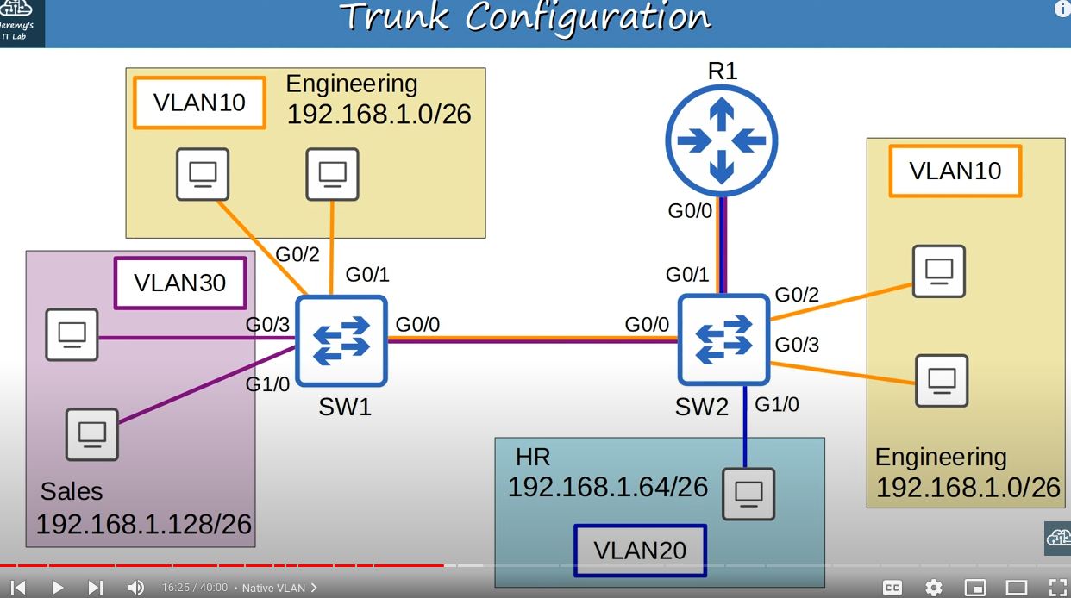
Trunk Configuration

Note: We will be configuring G0/0 on SW1,and G0/0 and G0/1 on SW2 as trunk ports.

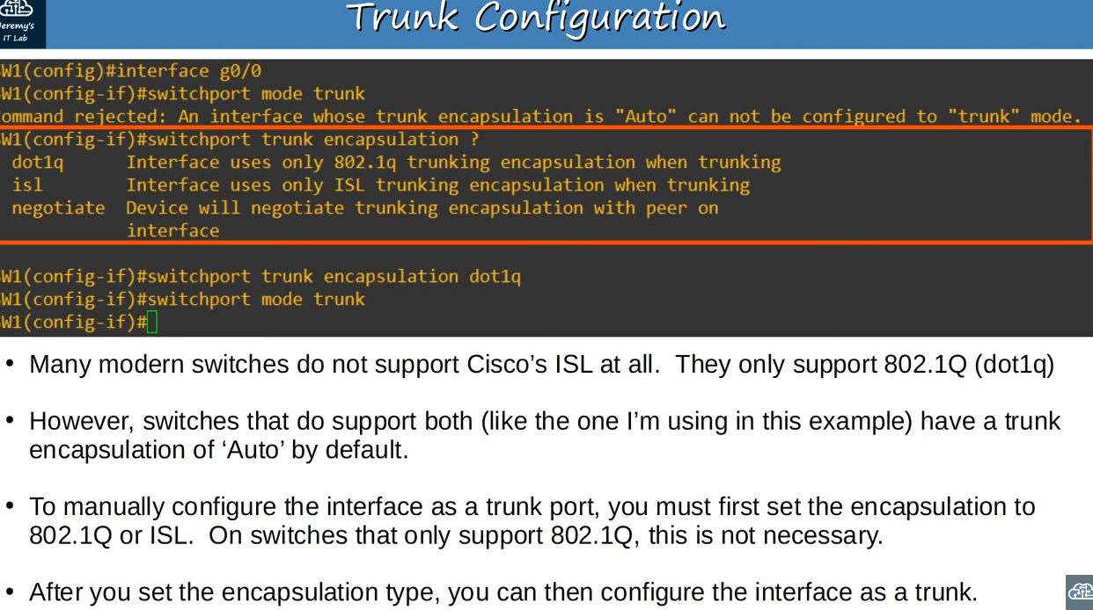
Trunk configuration in CLI(with probem occuring when switch supports both Cisco ISL and dot1q encapsulation types)

Note: After entering interface configuration mode,we use command ‘switchport mode trunk’ to manually configure the interface as a trunk.However in this case we got an error message(reason is written in the image)
Note: We use ‘switchport trunk encapsulation’ to set the encapsulation type.’negotiate’ option sets it to ‘Auto’(‘Auto’ will be covered in next lesson) mode.So we set the encapsulation type to dot1q, and this time the ‘switchport mode trunk’ command is accepted

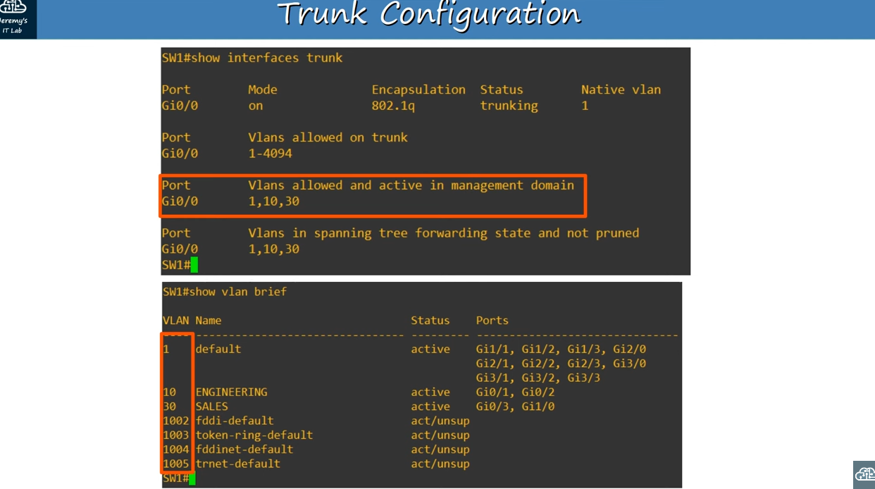
‘show interfaces trunk’ and ‘show vlan brief’ commands

Note: We use ‘show interfaces trunk’ command to confirm that trunk types are changed.The trunk interfaces are listed in the output of that command.’Mode on’ means that the interface was manually configured as a trunk.

Note: ‘Vlans allowed and active in management domain’ shows the defualt VLAN as well as VLANs 10 and 30, which we already configured on this switch.If some of VLANs are listed in ‘Vlans allowed on trunk’ but not listed in ‘Vlans allowed and active in management system’,that means that they are allowed on current switch but switch won’t receive any traffic from that VLAN,that’s because VLAN does not exist on current switch.So it means that we should create that VLANs on current switch,to receive traffic from that VLANs.

Note: Although VLAN 1,which exists by default,appears here,VLANS 1002 to 1005(displayed in the output of ‘show vlan brief’ command),which we saw in the previous lesson,do not.
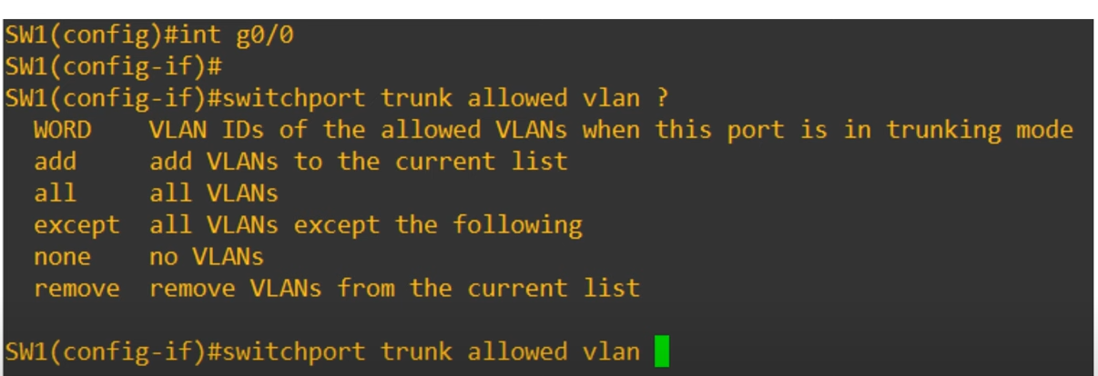
‘switchport trunk allowed <vlan_numbers>’ command options

Note: ‘WORD’ option allows to simply configure the list of VLANs allowed.

Note: ‘all’ is used to allow all VLANs(from 1 to 4096).It is the default state,as all VLANs are allowed by default.

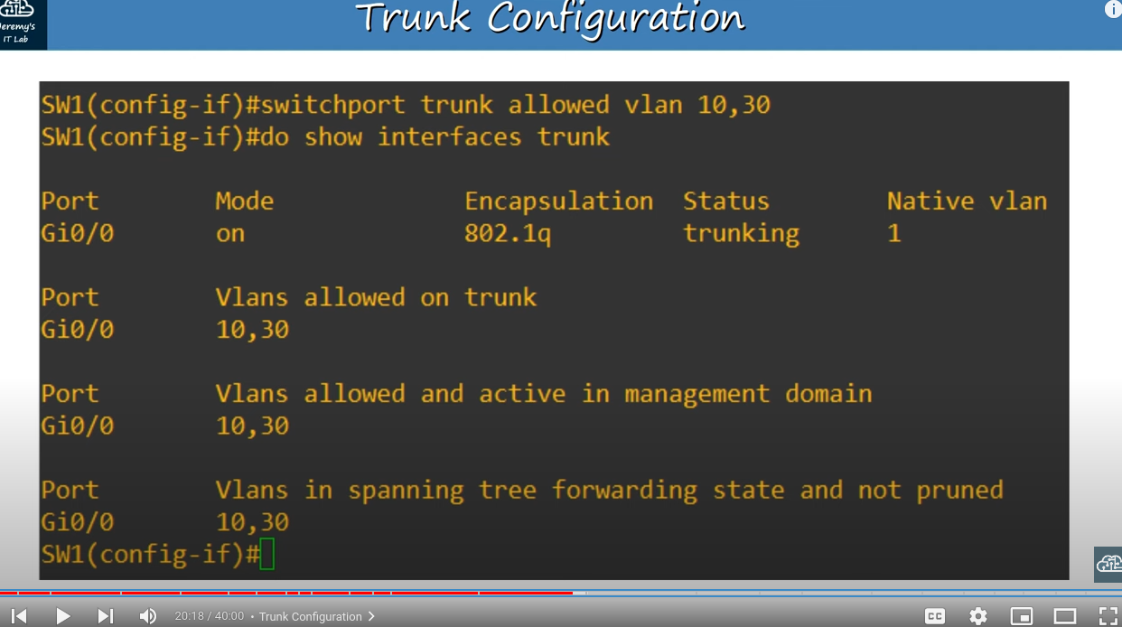
‘switchport trunk allowed <vlan_numbers>’ command

Note: This command configures VLANs on a trunk.

Note: When we used this command,it showed only the VLAN 10 and 30 being allowed on the trunk.

Note: We can use ‘add’ option to add allowed VLANs to the currently existing list.So if we want to add VLAN20 to the existing list,even though no hosts in VLAN20 are connected to SW1,we use command ‘switchport trunk allowed vlan add 20’ command.
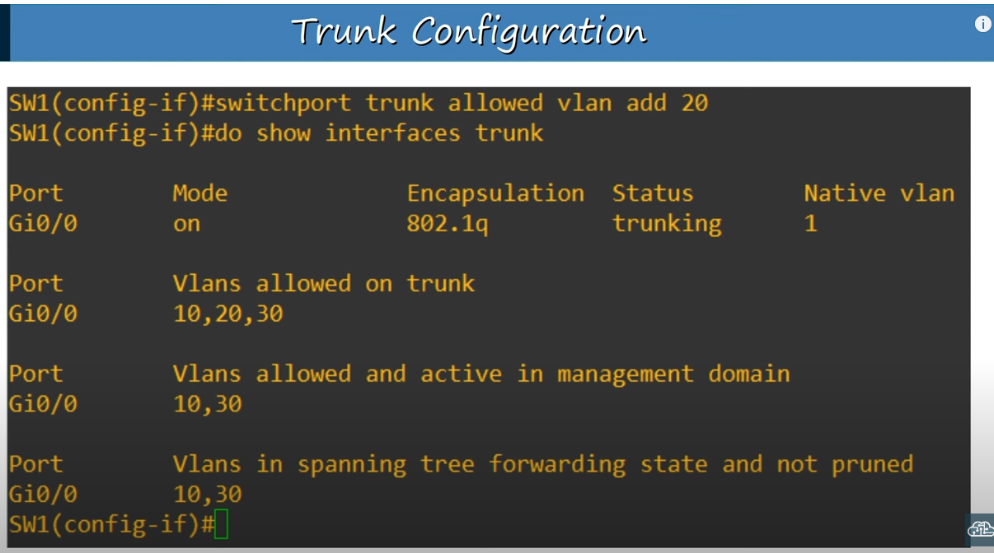

After using ‘switchport trunk allowed vlan add 20’ command

Note: Because we have not actually created VLAN20 on the switch, VLAN20 still isn’t displayed in the ‘Vlans allowed and active in management domain’

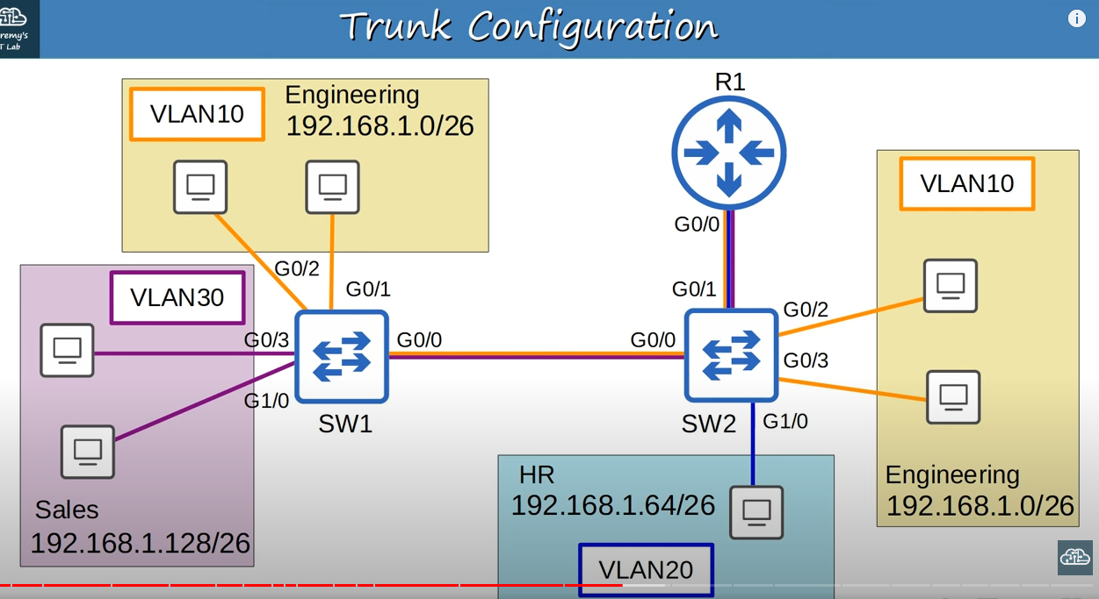
Doing actual settings for this network

Note: No hosts in VLAN20 are connected to SW1,so there’s no need to allow VLAN20 on the trunk between SW1 and SW2.So we set VLAN10 and VLAN30 on SW1.

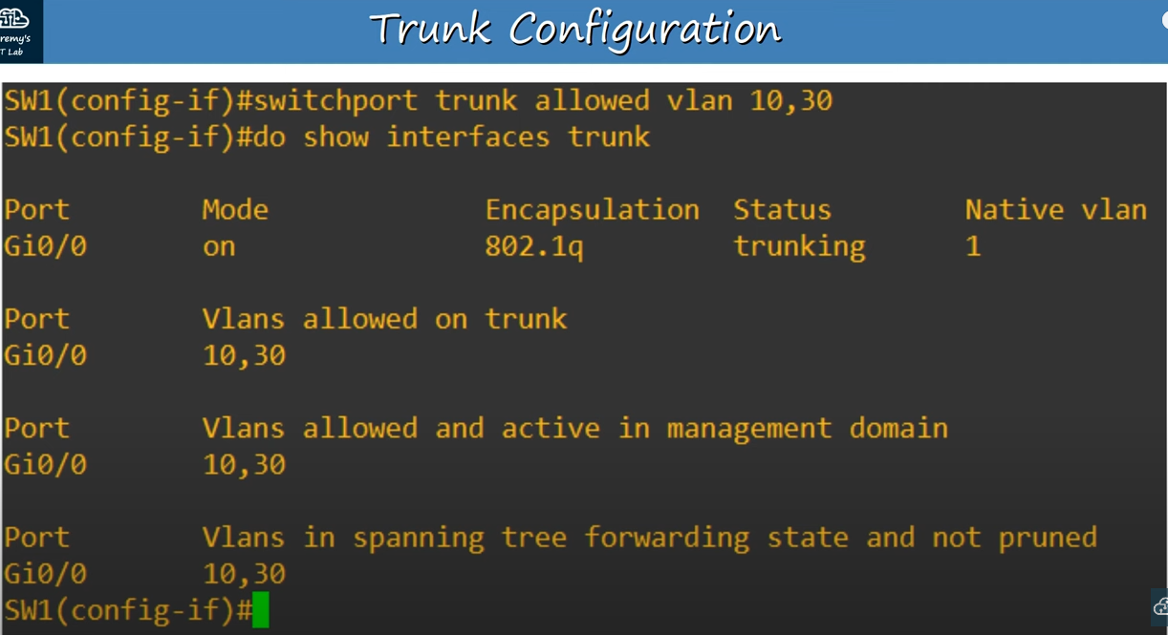
Trunk configuration on SW1

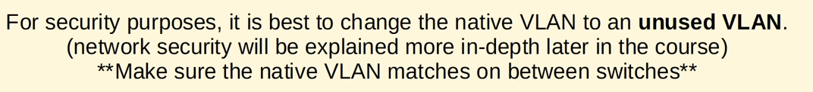
Note:

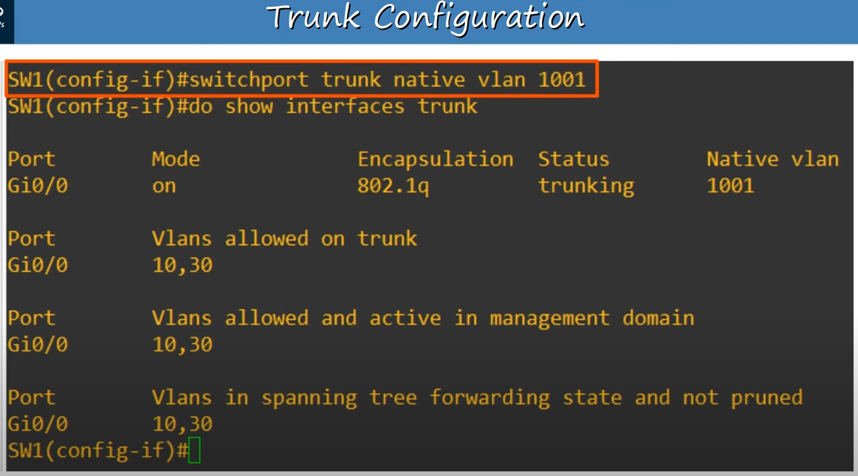
‘switchport trunk native vlan <vlan_number>’ command
Note: This command is used to change the native VLAN.So on Gi0/0 interface Native vlan changed to 1001(from the output of ‘do show interfaces trunk’)

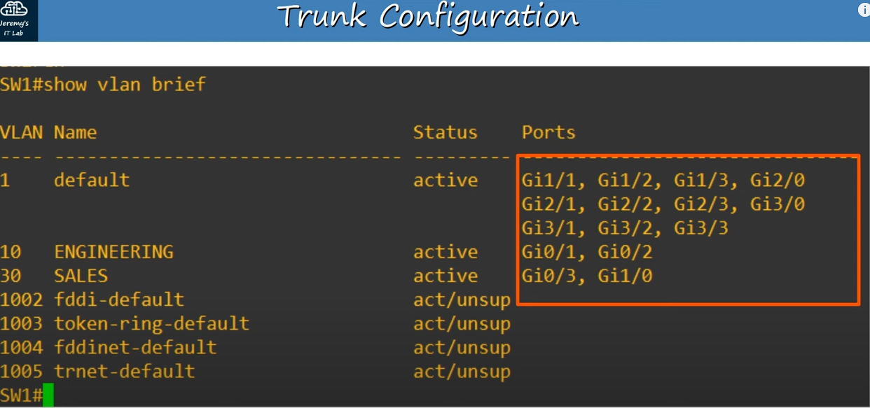
‘show vlan brief’ command(after configuring

Note: Gi0/0 interface is not listed anywhere.This is because ‘show vlan brief’ command shows the access ports assigned to each VLAN.
Instead we use ‘show interfaces trunk’ command to confirm trunk ports.
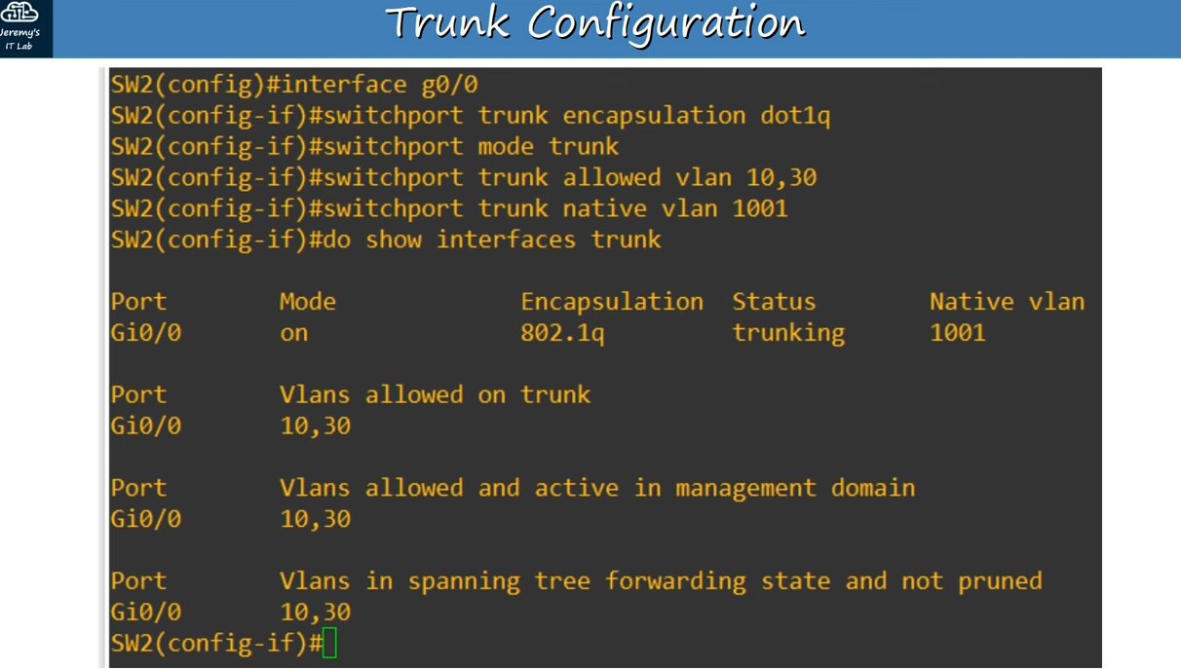
SW2’s Gi0/0 interface configurations

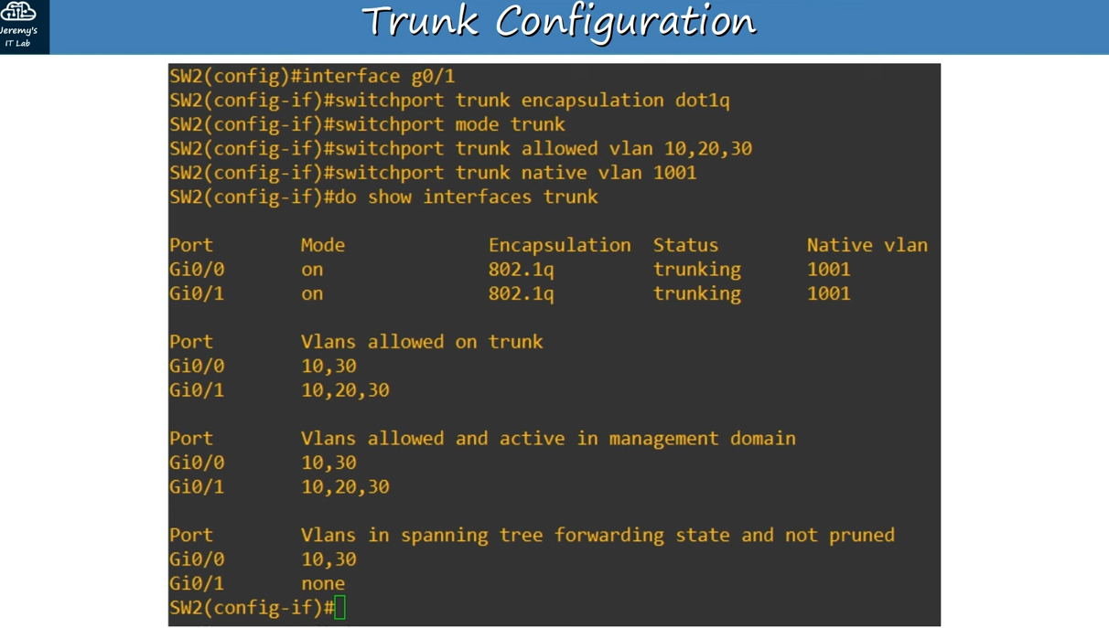
SW2’s G0/1 interface configurations,which is connected to R1

Note: In difference to Gi0/0 interface we also allowed VLAN 20.

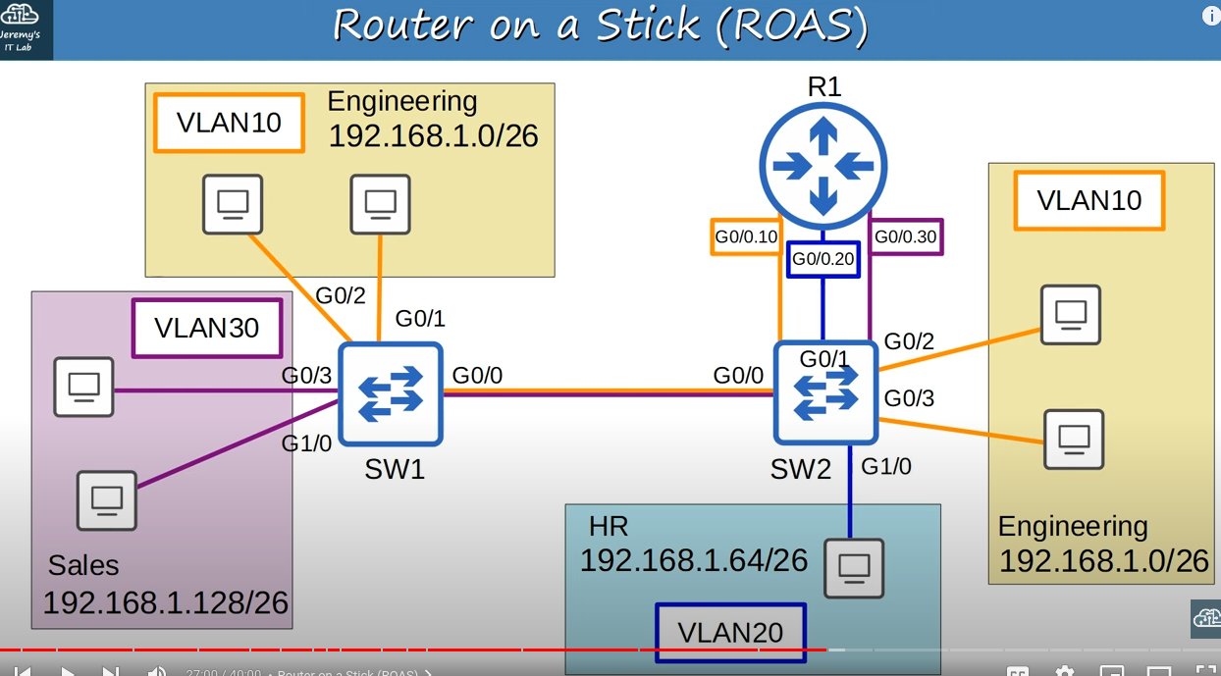
Inter-VLAN routing with ROAS

Note: ROAS is the name used for this method of Inter-VLAN routing,as there is only a single physical interface connecting the router and the switch.

Note: We can actually divide this one physical connection into three subinterfaces,which will allow us to perform inter-VLAN routing with only one physical connection,but they can operate like three separate interfaces.So it would look like this G0/0.10 for VLAN10, G0/0.20 for VLAN20,and G0/0.30 for VLAN 30.So to configure them as three separate subinterfaces we should only configure the router,not the SW2,we already configured G0/1 as a trunk on SW2,and made VLANs 10,20,30 allowed.

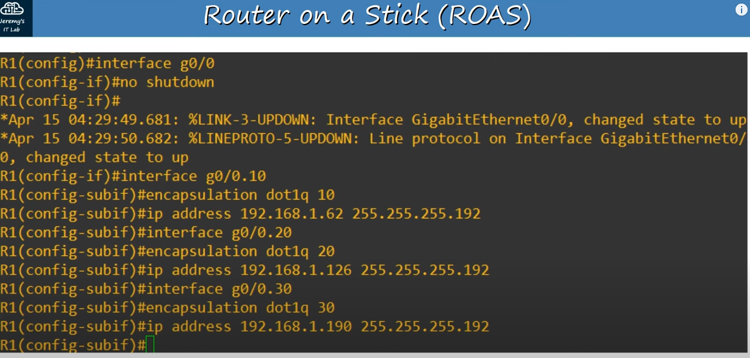
Router configurations

Note: To enter subinterface configuration mode we use ‘interface <interface_with_subinterface>’.The subinterface number(.10 for example for VLAN10) does not have to match the VLAN number.However it is highly recommended that they do match,to make it easier to understand.

Note: ‘encapsulation’ command tells the router to treat any arriving frames tagged with the specified VLAN number,as if they arrived on this subinterface.For example,if a frame arrives tagged with VLAN10,R1 will behave as if it arrived on interface G0/0.10.It will also tag all frames leaving this subinterface with VLAN10 using dot1q.Also we assign IP addresses(last usable IP addresses of each VLAN) to each subinterface.

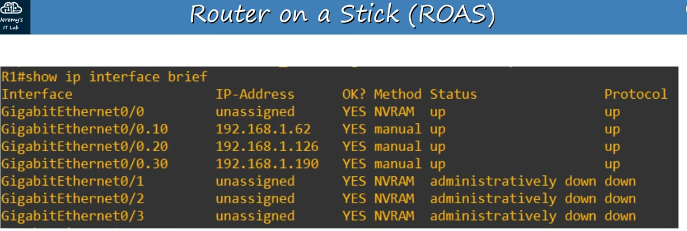
Confirming each subinterface with ‘show ip interface brief’ command

Note: We can see that each of the subinterfaces appears,as well as the physical interface.

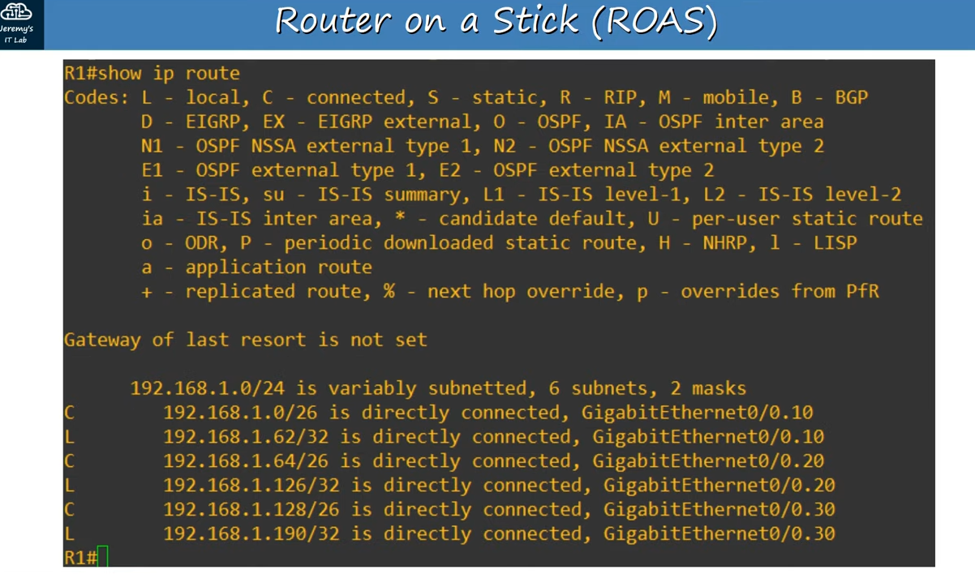
Routing table after configuring subinterfaces

Note: After configuring the subinterfaces,local and connected routes are added.

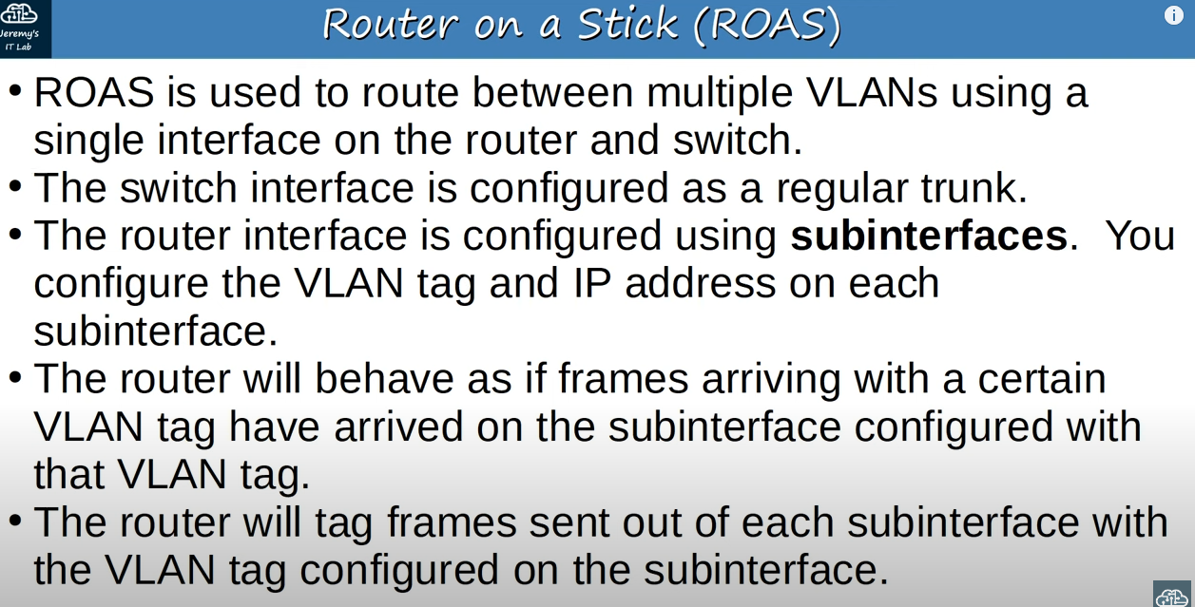
About ROAS

Note: If some of VLANs are listed in ‘Vlans allowed on trunk’ but not listed in ‘Vlans allowed and active in management system’,that means that they are allowed on current switch but won’t receive any traffic from that

